### ZENKINS

1

A WEBSITE TO COMBAT COVID-19

A Mini project Abstract submitted in the partial fulfillment of the requirement for the degree of Bachelor of Technology in

Computer Science & Information Technology

### Submitted By

SUBHAM JAIN 1901227338

RUKAIYA KHAN 1901227349

RAHUL KUMAR 1901227310

C.V. RAMAN GLOBAL UNIVERSITY



CERTIFICATE

This is to certify that the work in this project report entitled “ZENKINS : A website to combat COVID-19" submitted by Rukaiya Khan, Subham Jain and Rahul Kumar for partial fulfillment of the requirements for the award of Bachelor of Technology in Computer Science and information technology to C.V. Raman Global University, Odisha is a Bonafide work of research carried out by them under my supervision and guidance.

To the best of my knowledge and belief, this work has not been submitted to any other University or Institution for the award of any degree. In my opinion, the project fulfils the requirement of the regulations relating to the nature and standard of work for bachelor of technology of CGU-Odisha in Computer Science and Information technology.

# Acknowledgement

It is difficult to acknowledge the precious debt of knowledge and learning. But we can only repay it through our gratitude. First and foremost, I wish to express my profound gratitude to the almighty. It is my privilege to express my sincere thanks to DR.

Subhashish Das Mohapatra who has always been a constant source of inspiration. All the faculty members have helped me during the preparation of report by spending their precious time

Last but not the least I would like to thank my parents, friends for their co-operation and continuous support during the course.

### ……………………………….

Rukaiya Khan

Subham Jain

Rahul Kumar

### CONTENTS

Abstract

|  |
| --- |
| 5 |
| 6 |
| 7-9 |
| 10-11 |
| 12 |
| 13-14 |
| 15 |
| 16 |
| 17 |
| 18 |
| 19 |
| 20 |
| 21 |
| 22 |
| 23 |
| 23 |
| 23 |
| ------ |

1: Introduction

1. Web Development
2. Website
3. Web Page
4. UI Development
5. Responsive Web Design
6. Front-End Technology
7. E-commerce WebDevelopment
8. Technology Enhancement
9. Features
10. Advantages and Disadvantages
11. Software Requirements and Specifications 2: Testing Results
12. Logo
13. Analysis Results
14. Responsive View 5:Conclusion
15. Future Work
16. Bibliography

### ABSTRACT

This website contains all the basic information which is all you need to know about corona virus. We have also provided all the detailed explanations of the questions that have been asked around the globe. We have provided the information about every essential equipment and medicines like sanitizer, masks, gloves, paracetamol etc. We have also provided the links to the websites like amazon and flipkart from which you can directly buy those equipments and medicines online easily. This website mainly deals with every essentials to combat covid-19.

The Technology used here are: -

### HTML used for making up all the body of the website.

* + CSS stands for Cascading Style Sheets which helps HTML to gives design
  + shades
  + JavaScript (JS) allows you to make web pages interactive.
  + Widgets: - easy-to-use software application or component made for one or more different software platforms.

1. INTRODUCTION

A digital web presence enables content such as texts, images, and videos to be displayed on the internet. There are many reasons why business people need a **representative website:** to inform potential customers about products and services, to represent the company, to enable contact with different departments, or to distribute goods online. For private users, a website gives them the chance to actively take part in public affairs. There are also personal sites that contain informative material or are used for entertainment. An overview of the most popular sites can be found below.

By placing a link to your own website next to your social network profile, you increase the chances of catching the attention of potential employers, interested parties, or like-minded people.

A website’s large reach is certainly one of the reasons for the growing number of internet sites in recent years

All publicly accessible websites collectively constitute the [World Wide Web](https://en.wikipedia.org/wiki/World_Wide_Web). There are also private websites that can only be accessed on a [private network](https://en.wikipedia.org/wiki/Intranet), such as a company's internal website for its employees.

Websites are typically dedicated to a particular topic or purpose, such as news, education, commerce, entertainment, or [social networking](https://en.wikipedia.org/wiki/Social_networking). [Hyper linking](https://en.wikipedia.org/wiki/Hyperlink) between web pages guides the navigation of the site, which often starts with a [home page](https://en.wikipedia.org/wiki/Home_page).

OBJECTIVE

This website is designed to combat covid-19,a virus which has created a huge impact all over the world and has been affecting lives of human beings drastically. We know that due to lockdown In almost every countries everything has to come to our digital screens through internet because things can’t be stopped completely and everyone has to operate from home.

This website contains all the basic information which is all you need to know about corona virus. We have also provided all the detailed explanations of the questions that have been asked around the globe.

As this virus affects human body and we don’t have any vaccines and antibodies created to counter it we can’t take risks, so we have to take every major precaution against it and for that we have provided the information about every essential equipment and medicines like sanitizer, masks, gloves, paracetamol etc. We have also provided the links to the websites like amazon and flipkart from which you can directly buy those equipments and medicines online easily.

1. WEBSITE DEVELOPMENT

Web development can simply be defined as the building and maintenance of websites for hosting via the internet or the intranet (a private network).

It’s all about creating web pages (websites) or applications (such as Amazon or Facebook) that run in a web browser. Web development often involves learning several programming languages, frameworks, databases, etc. as different websites and apps use different technologies and have different functionalities.

Among web professionals,"web development" usually refers to the main non-design aspects of building web sites: writing markup and coding. Most recently Webdevelopmenthascometomeanthecreationofcontentmanagementsystemsor CMS. These CMS can be made from scratch, proprietary or open source. In broad terms the CMS acts as middleware between the database and the user through the browser. A principle benefit of a CMS is that it allows non-technical people to make changes to their website without having technical knowledge. For larger organizations and businesses, web development teams can consist of hundreds of people (web developers) and follow standard methods like Agile methodologies while developing websites. Smaller organizations may only require a single permanent or contracting developer, or secondary assignment to relate job positions such as a graphic designerorinformationsystemstechnician.Webdevelopmentmaybeacollaborative effortbetweendepartmentsratherthanthedomainofadesignateddepartment.There are three kind of web developer specialization: front-end developer, back-end developer, and full-stack developer.

WEB-SITE

A website is a collection of publicly accessible, interlinked Web pages that share a single domain name. Websites can be created and maintained by an individual, group, business or organization to serve a variety of purposes.

Together, all publicly accessible websites constitute the World Wide Web.

Although it is sometimes called “web page,” this definition is wrong, since a website consists of several web pages. A website is also known as a “web presence” or simply “site”.

A website should contain following components:-

* **Front End Elements.** People often describe the website as having a front end and back end. In this analogy, front end is what you see, back end is what you don’t. Simple enough, except that you can’t really see the navigation structure, not all at once. But it’s a place to start. Good front-end components include the following:
* **The navigation structure.** This is not the same as the sitemap, though that might represent it. The navigation structure is the order of the pages, the collection of what links to what. Usually it is held together by at least one navigation menu.
* **The page layout.** This is the way things appear on the page. Is the navigation menu on the top or along the side? Are there images above the text area? Tables? Good layout is as important as any other element of design. Bad layout makes a website look crowded and slapdash. Good layout allows the eye to find what it seeks easily.
* **Logo.** A good website has a unifying graphic around which it is built. The graphic represents your company, your organization. It often sets up the color scheme and the style elements used throughout. The logo ties the website to everything else your company does, though the printed materials, signs, whatever.
* **Images.** Photos, graphics, navigation bars, lines and flourishes, animations can all be placed on a website to bring it to life. Or, in some cases, bury it.
* **Contents.** Few websites exist just to be looked at. The internet began as a method of sharing information. As it evolved into the World Wide Web, it became rich in all kind of media. But it still exists primarily to communicate. Well written internet-ready text is a special kind of text. Usually the information is broken into readable chunks. It is formatted to be easily scanned, and it is often optimized for search engines as well as human eyes.
* **Graphic Design.** Many of the elements described, such as the logo, the navigation menus, the layout, images, etc., fall under the general category of graphic design. But graphic design is more than the sum of these parts. It is the overall look and feel the website will have as a result of proper use and integration of all these elements. A website with bad graphic design is usually obvious to everyone except the person who put it together. But doing graphic design well takes a special combination of talent, skill, and education.
* **Back End elements.** Some websites are entirely static. They are the same every time you visit. You never give them information, there are no polls, bulletin boards, or referral forms. If you want to find something on the website, there is no search box, you just look around until you find it. But such sites are growing more rare as the internet becomes an ever greater part of people’s lives. Modern sites are searchable. They offer new images on each visit. They allow the user to request more information, or to post their own thoughts. Many can be updated directly from a simple panel or word-processing program. A lot of websites are data driven, meaning that web pages are actually created on the fly, in response to the specific needs of the user. All of these functional elements are called back-end elements. In some cases there are many different ways to do the same thing. So the line between elements is often blurry.
* **Content Management System.** This is the ability to update your website without having to directly edit the html. A robust content management system allows for documents to be prepared, edited, approved, and tracked prior to publication. Simple systems create areas on a web page that can be easily changed on a regular basis.

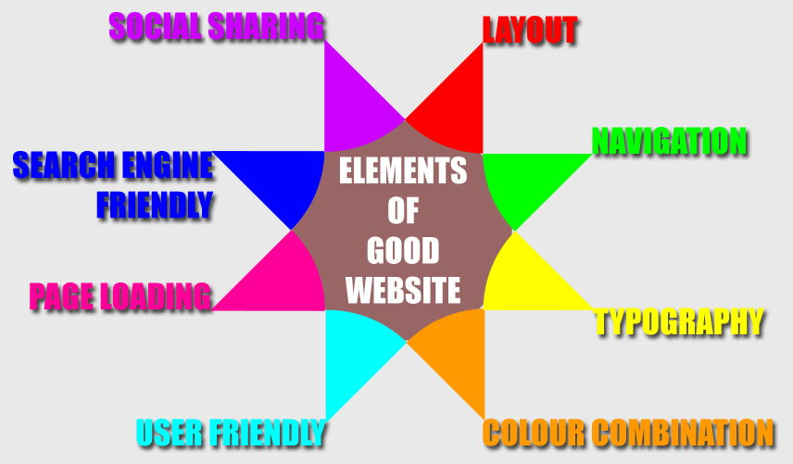

WEB-PAGE

Awebpage,orwebpage,isadocumentthatissuitablefortheWorldWideWeband webbrowsers.Awebbrowserdisplaysawebpageonamonitorormobiledevice.The webpageiswhatdisplays,butthetermalsoreferstoacomputerfile,usuallywritten inHTMLorcomparablemarkuplanguage.Webbrowserscoordinatethevariousweb resourceelementsforthewrittenwebpage,suchasstylesheets,scripts,andimages, to present the web page. Typical web pages provide hypertext that includes a navigationbarorasidebarmenutootherwebpagesviahyperlinks,oftenreferredto as links. On a network, a web browser can retrieve a web page from a remote web server.Onahigherlevel,thewebservermayrestrictaccesstoonlyaprivatenetwork suchasacorporateintranetoritprovidesaccesstotheWorldWideWeb.Onalower level, the web browser uses the Hypertext Transfer Protocol (HTTP) to make such requests.Astaticwebpageisdeliveredexactlyasstored,aswebcontentintheweb server'sfilesystem,whileadynamicwebpageisgeneratedbyawebapplicationthat isdrivenbyserver-sidesoftwareorclient-sidescripting.Dynamicwebsitepageshelp thebrowser(theclient)toenhancethewebpagethroughuserinputtotheserver.

UI DEVELOPMENT

Technologies that are mostly used to develop a User Interface are:

* HTML
  + HTMListhestandardmark-uplanguageforWebpages
  + HTMLelementsarethebuildingblocksofHTMLpages
  + HTML elements are represented by <>tags
  + HTML Stands for hyper-text mark-upLanguage
* CSS
* CSS stands for Cascading StyleSheets.
* CSSdescribeshowHTMLelementsaretobedisplayed

Responsive Website Design

Responsive Web design is the approach that suggests that design and development should respond to the user’s behavior and environment based on screen size, platform and orientation.

The practice consists of a mix of flexible grids and layouts, images and an intelligent use of CSS media queries. As the user switches from their laptop to iPad, the website should automatically switch to accommodate for resolution, image size and scripting abilities. One may also have to consider the settings on their devices; if they have a [VPN for iOS](https://www.expressvpn.com/vpn-software/vpn-ios) on their iPad, for example, the website should not block the user’s access to the page. In other words, the website should have the technology to automatically *respond* to the user’s preferences. This would eliminate the need for a different design and development phase for each new gadget on the market.

Onatinysmartphonescreen,websitescanbeevenmorechallengingtosee.Large imagesmay“break”thelayout.Sitescanbeslowtoloadonsmartphonesiftheyare graphicsheavy.

However, if a site uses responsive design, the tablet version might automatically adjust to display just two columns. That way, the content is readable and easy to navigate.Onasmartphone,thecontentmightappearasasinglecolumn,perhaps stackedvertically.Orpossiblytheuserwouldhavetheabilitytoswipeovertoview othercolumns.Imageswillresizeinsteadofdistortingthelayoutorgettingcutoff. Thepointis:withresponsivedesign,thewebsiteautomaticallyadjustsbasedonthe device the viewer sees itin.

Responsivesitesusefluidgrids.Allpageelementsaresizedbyproportion,ratherthan pixels.Soifyouhavethreecolumns,youwouldn’tsayexactlyhowwideeachshould be, but rather how wide they should be in relation to the other columns. Column 1 shouldtakeuphalfthepage,column2shouldtakeup30%,andcolumn3shouldtake up 20%, forinstance.

Mediasuchasimagesisalsoresizedrelatively.Thatwayanimagecanstaywithinits column or relative designelement.

FRONT END METHODOLGY

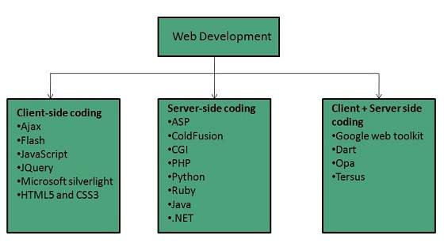

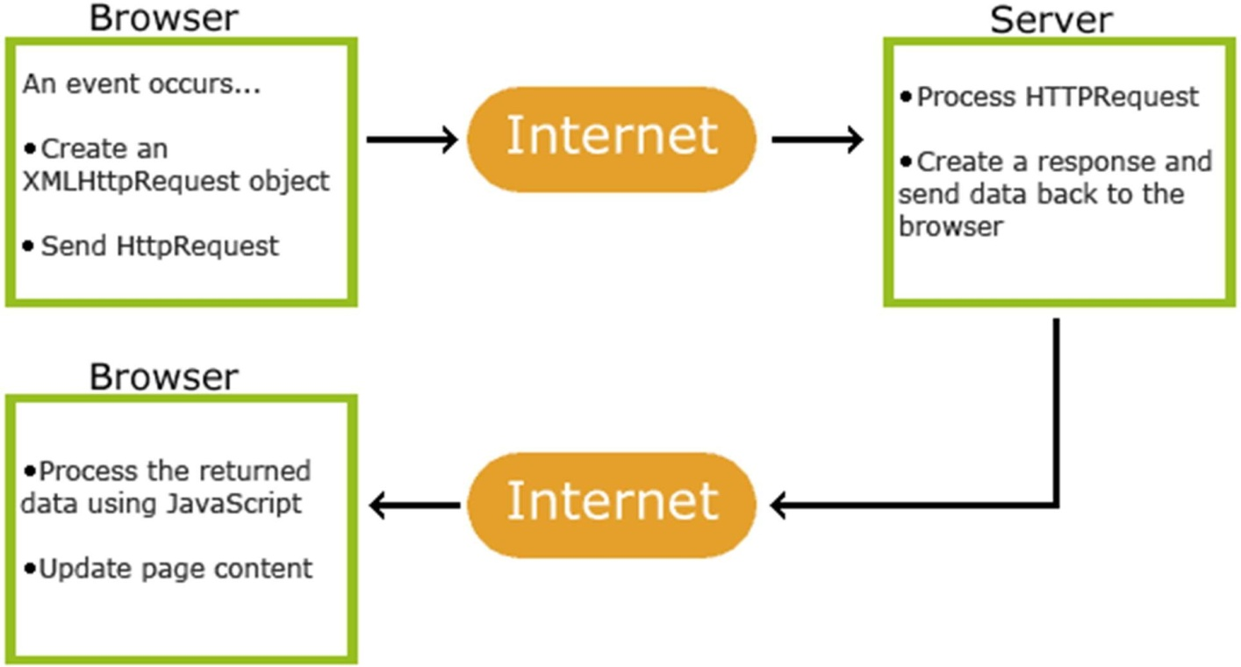

7

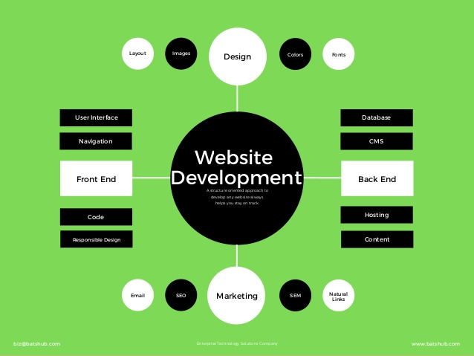

E-Commerce Website Development

E-Commerce websites are online portals that facilitate online transactions of goods andservicesthroughmeansofthetransferofinformationandfundsovertheInternet. Intheearlydays,e-commercewasdonepartiallythroughemailsandphonecalls.

Now, with a single website, anything and everything that a transaction needs, can be executed online.

Types of E-Commerce websites

DifferenteCommercewebsitesarelabelledorreferredtodifferently,basedonthe function theyfulfil.

* Business-to-Business(B2B):Electronictransactionsofgoodsandservices between companies. Example: A business sells SAS products to other businesses.
* Business-to-Consumer(B2C):Electronictransactionsofgoodsandservices betweencompaniesandconsumers.Example:Youbuyanewt-shirtfrom an onlinestore.
* Consumer-to-Consumer (C2C): Electronic transactions of goods and servicesbetweenconsumers,mostlythroughathirdparty.Example:You sellyouroldsmartphoneoneBayorOlxtoanotherconsumer.
* Consumer-to-Business(C2B):Electronictransactionsofgoodsandservices where individuals offer products or services to companies. Example: A Social media influencer offers exposure to their online audience in exchange for afee.

eCommerceisnothingbutatypeofcommerce.Itsfunctioningstyleisquitesimilarto thatofthephysicalretailindustry.Theonlydifferenceithaswithabrickandmortar storeisthathere,theentireprocesstakesplaceonline.

Customers are usually asked to place their orders by filling up a form. There, they needtoprovideallthenecessarydetailslikethedeliveryaddress.Therearedifferent payment methods used in the eCommerce industry. Buyers either can make the paymentthroughapaymentgatewaylikePayPalortheycanusetheircreditcards.

ThereisanotheroptioncalledCODorcashondelivery.Thisismainlypreferredby seniorcustomers.Inthisoption,thebuyermakesthepaymentwhentheitemthey orderedisdeliveredontheirpersonaladdress.Thepaymentcanbemadeeitherin cashorthroughcardsorotherconvenientoptionslikeGooglePay.

TECHNOLOGY ENHANCEMENT

OurHouseStoreisaE-commerceWebDevelopmentwhichisbasicallyafront-end WebDevelopmentwhichhasfollowingtechnicalSpecifications:-

* HTML (hyper-text mark-up Language): - HTML is the standard mark- up language for Web pages. HTML elements are the building blocks of HTML pages. HTML elements are represented by <>tags.
* CSS (Cascading Style Sheets): - Cascading Style Sheets is a style sheet language used for describing the presentation of a document written in a markup language such asHTML.
* JS(JavaScript):-isaprogramminglanguagethatconformstotheECMAScript specification. JavaScript is high-level, often just-in-time compiled, and multi- paradigm.Ithascurly-bracketsyntax,dynamictyping,prototype-basedobject- orientation, and first-classfunctions.
* Widgets:-Awebwidgetisawebpageorwebapplicationthatisembeddedas an element of a host web page but which is substantially independent of the hostpage,havinglimitedornointeractionwiththehost.

The above four specifications result out to our project “The House Store”.

FEATURES

Our Website has following features: -

* Multi page Website:- Our Website is multi paeandwithaproper UI and use of colors. Italsohas self- customized logo
* Category List: - As it is an E-commerce website it has category list which is an attractionpointinwebsite.Ithas15categoriesofproducts.
* Validated Forms: - Each and every form in the website is validated means leaving them null will not work.
* Bootstrap:- we have used bootstrap for easily accessible use of predefined classes
* NumberofViewers:-Thewebsitehasnumberofviewersvisitedwebsitewhichwill enhance our website

### ADVANTAGES AND DISADVANTAFES OF WEBSITE

1. Advantages of Website:-
   * Variety of information
   * Access to different shopping websites directly
   * Answers to the questions asked globally
   * Easily accessible and convenient
2. Disadvantages of Website:-
   * Unable to examine product externally.
   * Limitations over the internet usage.
   * Possibility of phishing of data.

# Software Requirement Specifications

The selection of hardware is a very important in the existence and proper working of any software and when selecting hardware size requirement is also important.

|  |  |
| --- | --- |
| RAM- 4GB | Windows:- 8/7/10 |
| Internet Connectivity | CHROME /FIREFOX/ EXPLORER |

CUSTOMIZED LOGO OF THE WEBSITE



TESTING AND ANALYSIS RESULTS

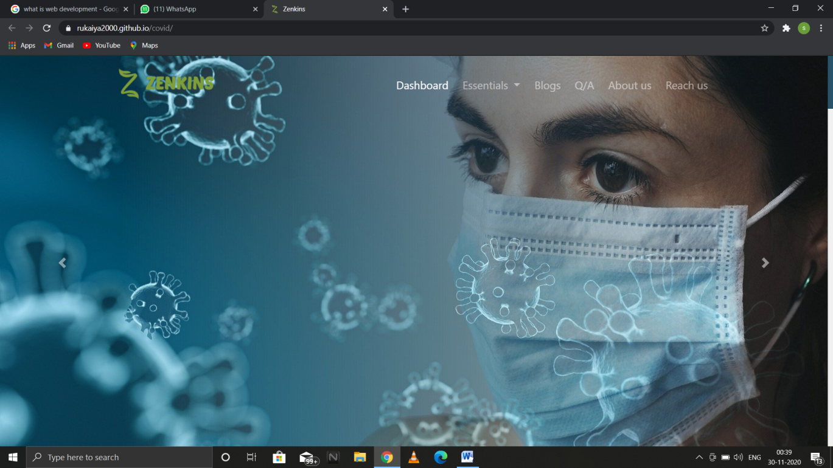

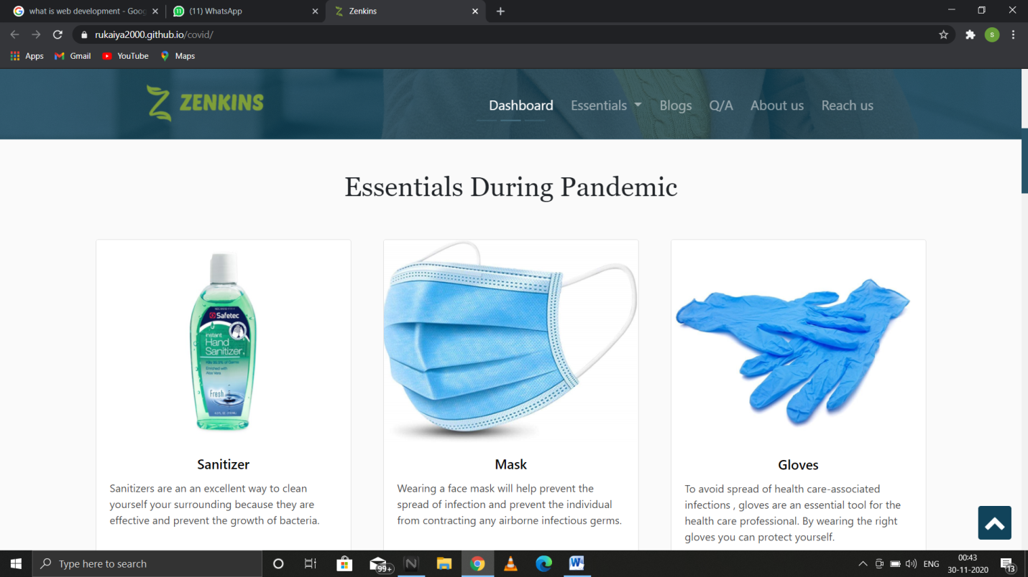

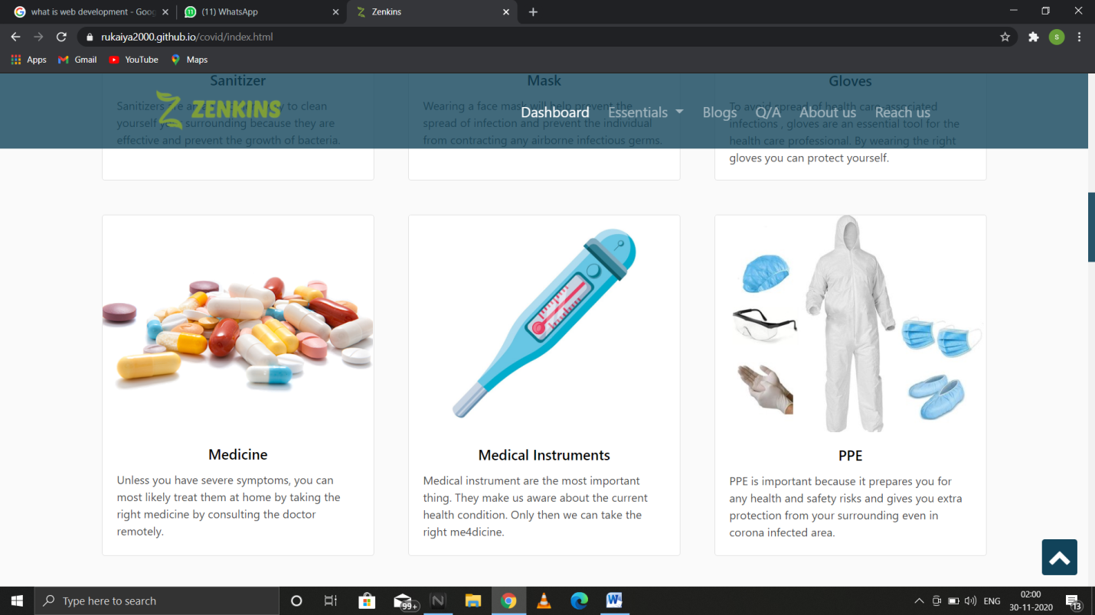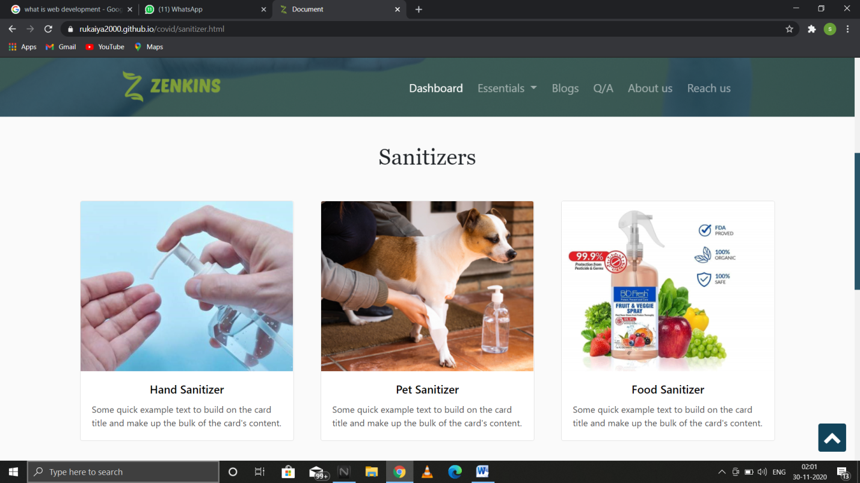

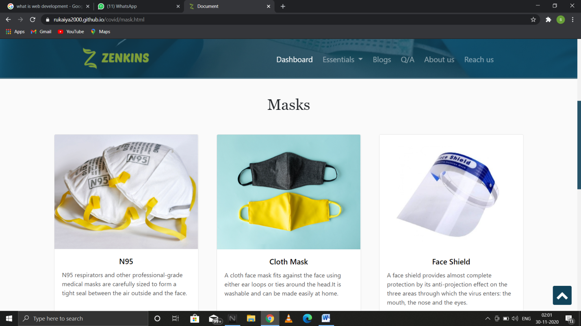

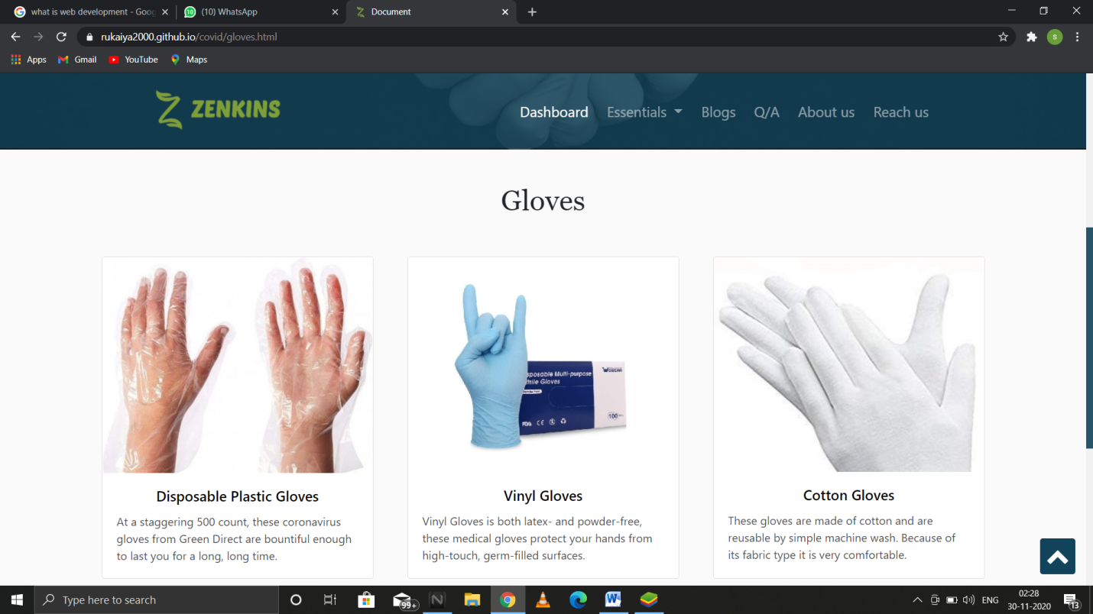

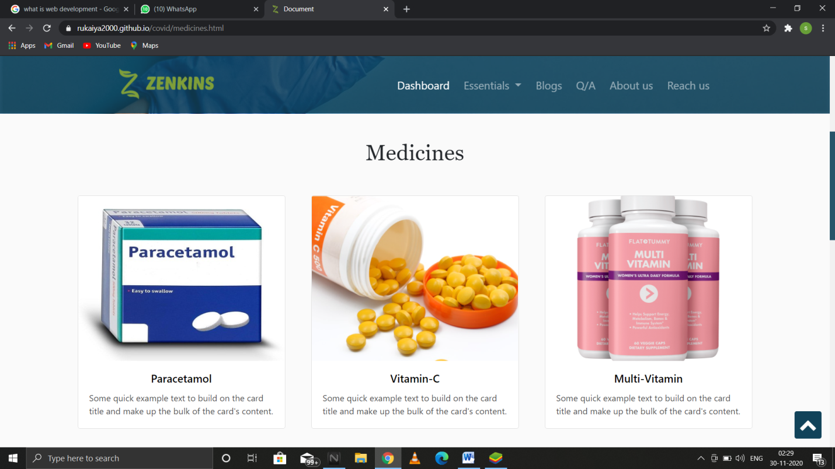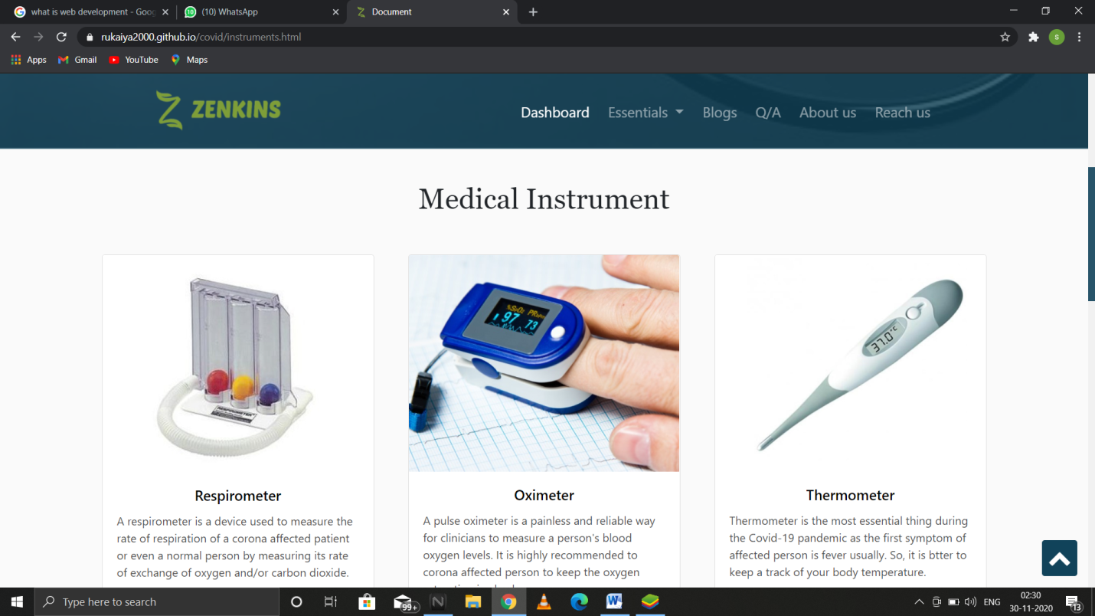

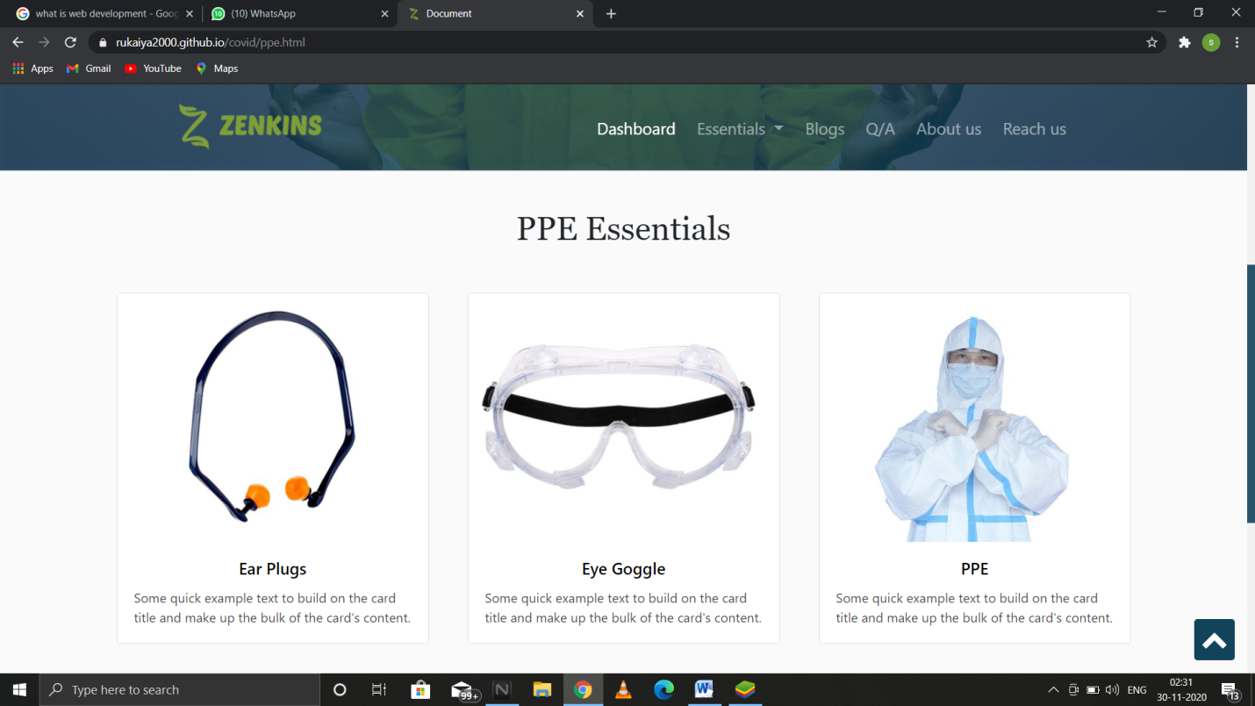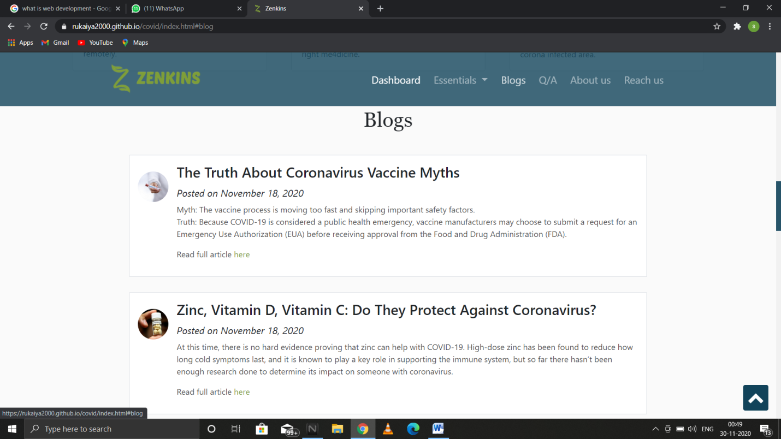

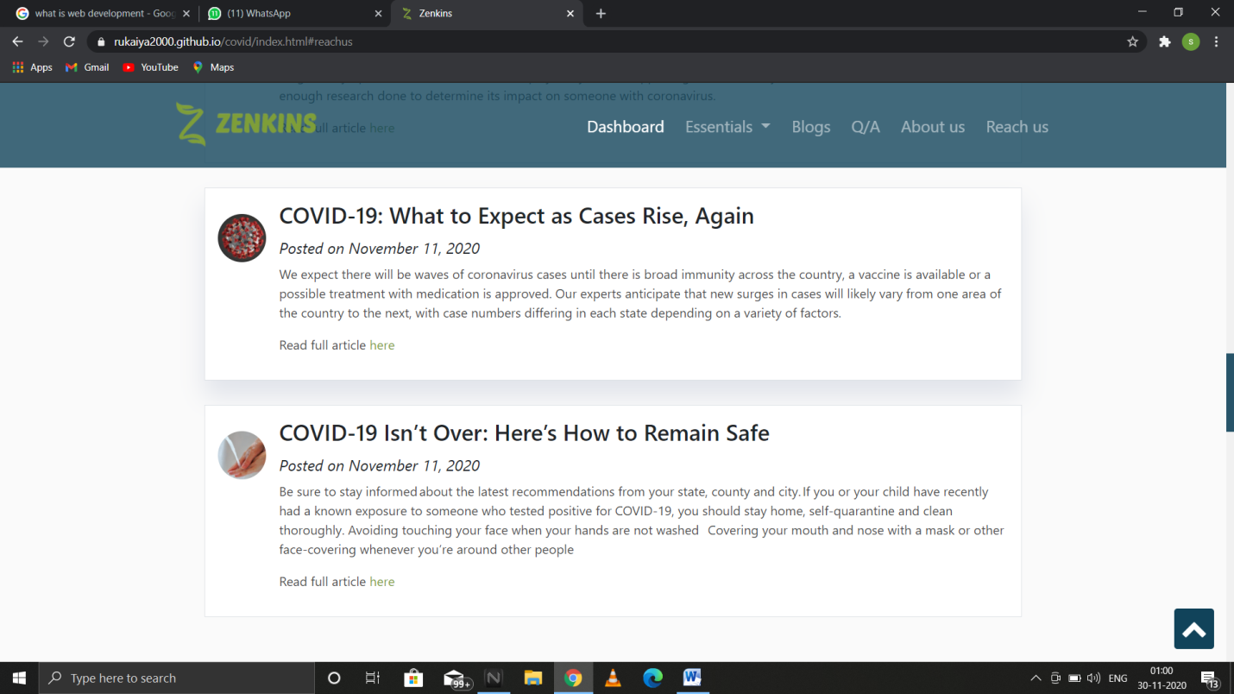

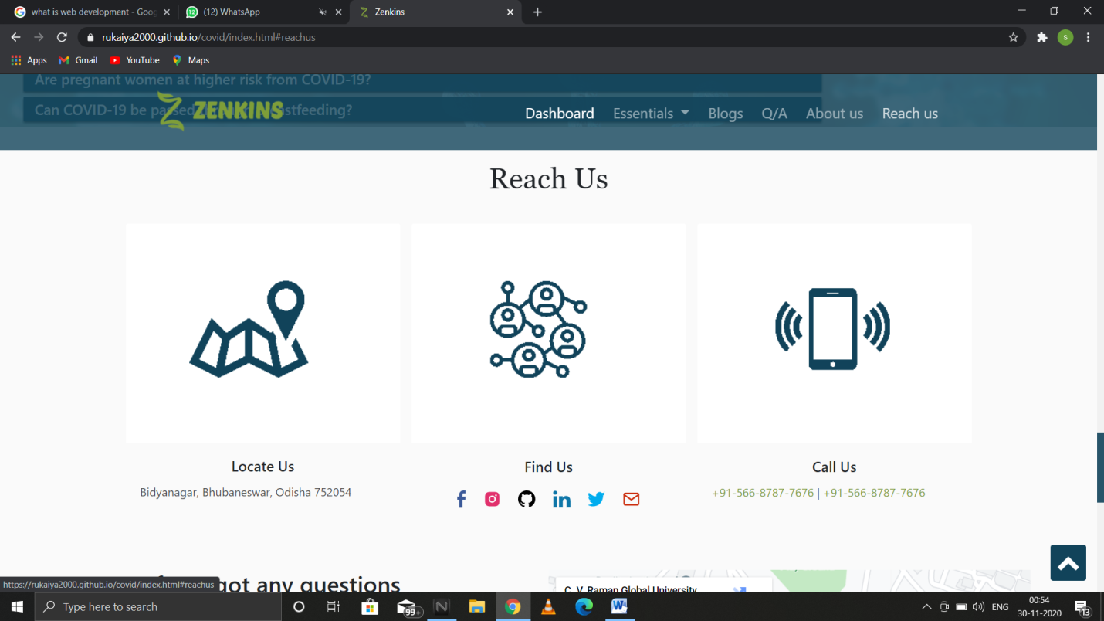\

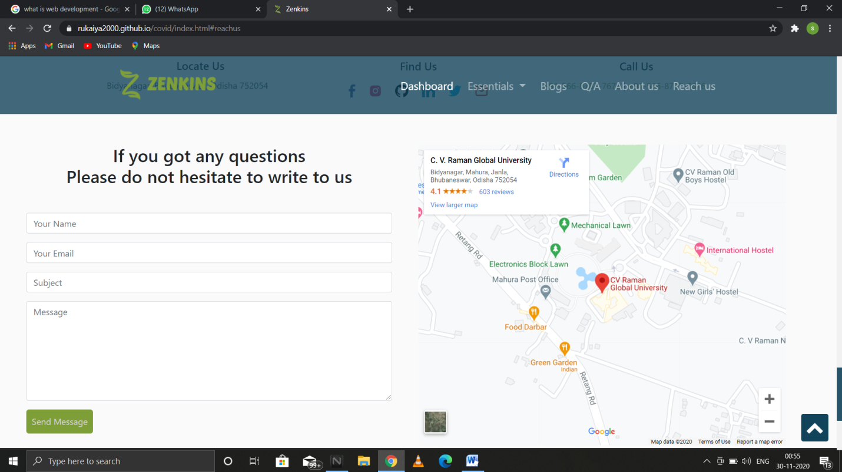

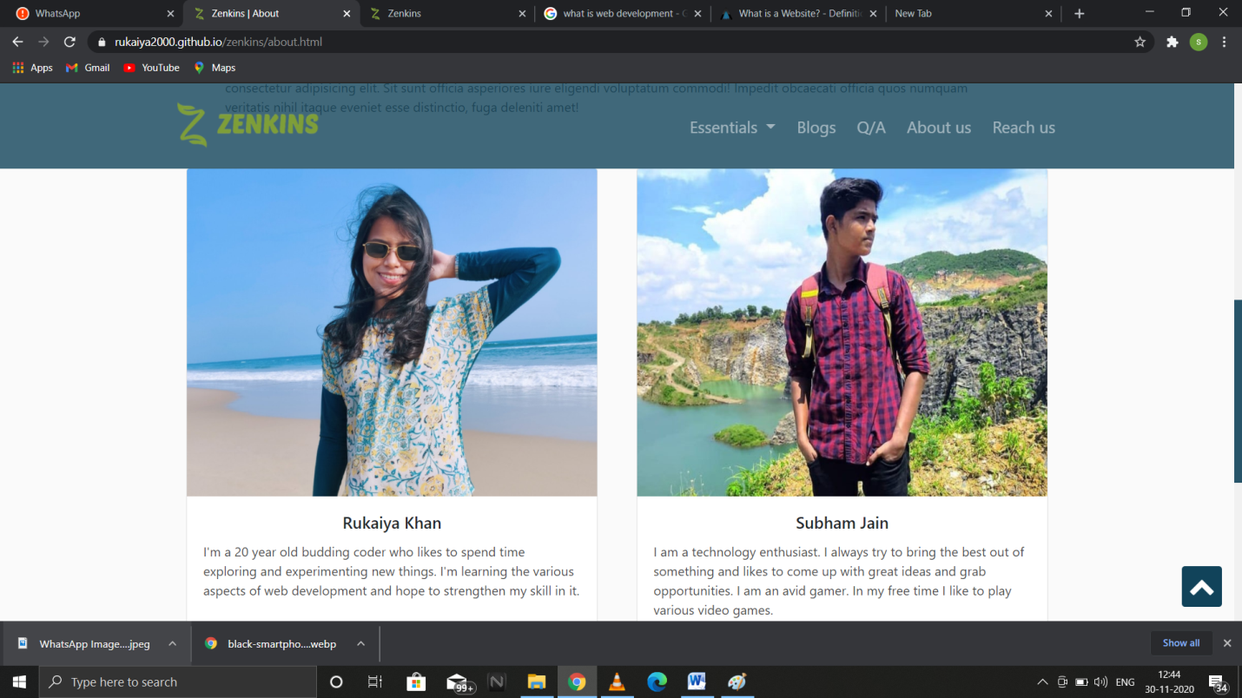

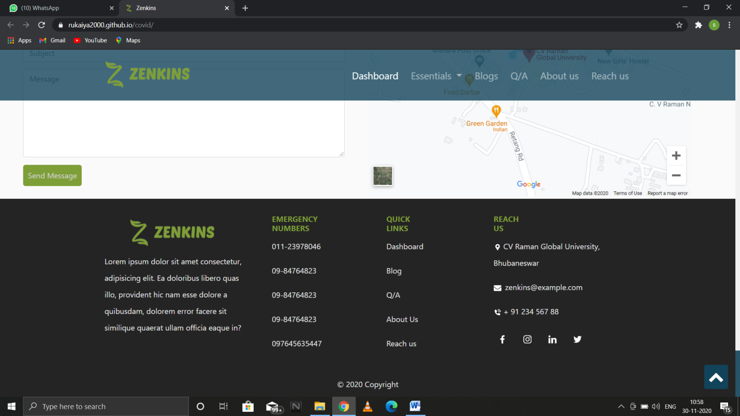

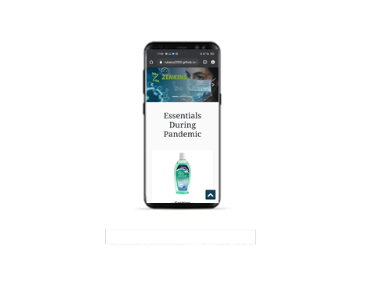

## https://rukaiya2000.github.io/zenkins/

CONCLUSION

We have successfully made a corona website which can be used by common people for their daily life. We have hosted the projected in github. People can use this file for ecommerce purpose as well.

## FUTURE WORK

A work started has a future so the future of our online store is listed as following:

* Android App Development
* Database Connectivity
* Full Stack Website
* API Implementation

## BIBLIOGRAPHY

* W3schools: -https://[www.w3schools.com/](http://www.w3schools.com/)
* Stackoverflow: - https://stackoverflow.com/
* For bootstrap : <https://getbootstrap.com/docs/4.1/getting-started/introduction/>